**ITCS – 6162 Knowledge Discovery in Databases**

**Project dataset – iris data**

After the data is loaded, it is split into training and testing data sets, 75% training set and 25% test dataset

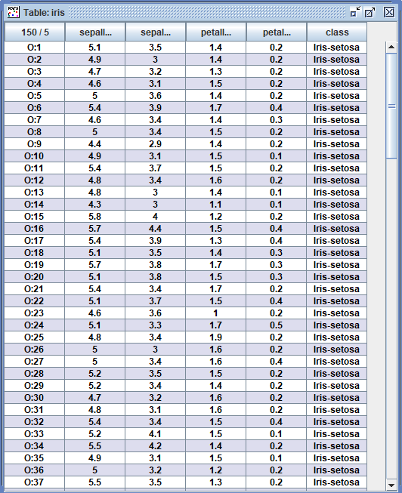

**Rules set – diabetes data**

Rules generated with 75% of input split into training data for building rules using Exhaustive algorithm

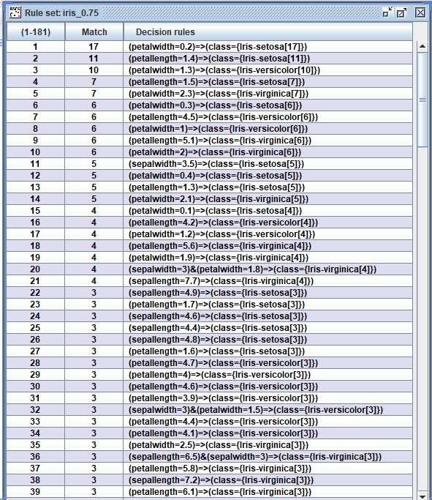

**Classification results – diabetes data**

Test the rules that were calculated using training data on the 25% of the Test Data. We used Standard Voting to resolve conflict and generated Confusion Matrix

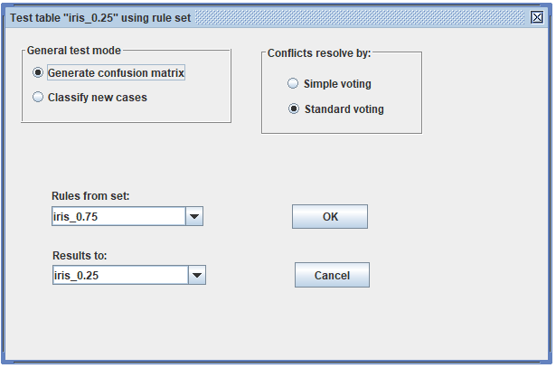

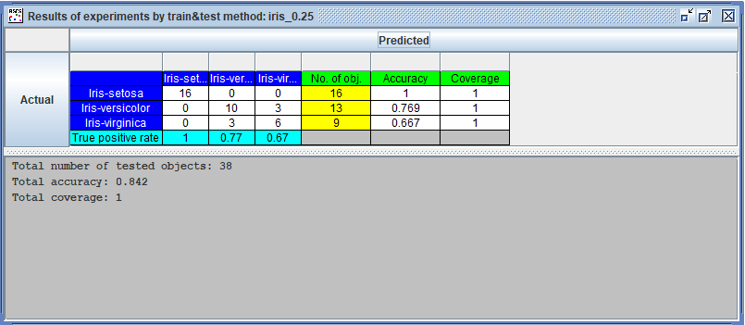

**RSES windows after the end of train-and-test scenario with use of rule-based classifier**

